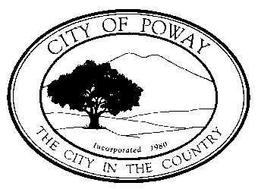
City of Poway
Preparation Date:
Storm Water Intake Form for All Permit Applications

This form must be completed in its entirety and accompany applications for any of the discretionary or ministerial permits and approvals referenced in Sections 16.100 through 16.105 of the City of Poway Municipal Code (PMC). The purpose of this form is to establish the Stormwater Quality Management Plan (SWQMP) requirements applicable to the project.
Step 1: Project Identification
Applicant name: | APN: | Project/Permit Number:
Project Address:

Step 2: Geographic location
Step |  |  |  |  | Answer
What hydrologic unit is the project in? Use the map below to approximate the location. |  |  |  |  | ☐905.31 ☐905.21  ☐905.22 ☐906.20
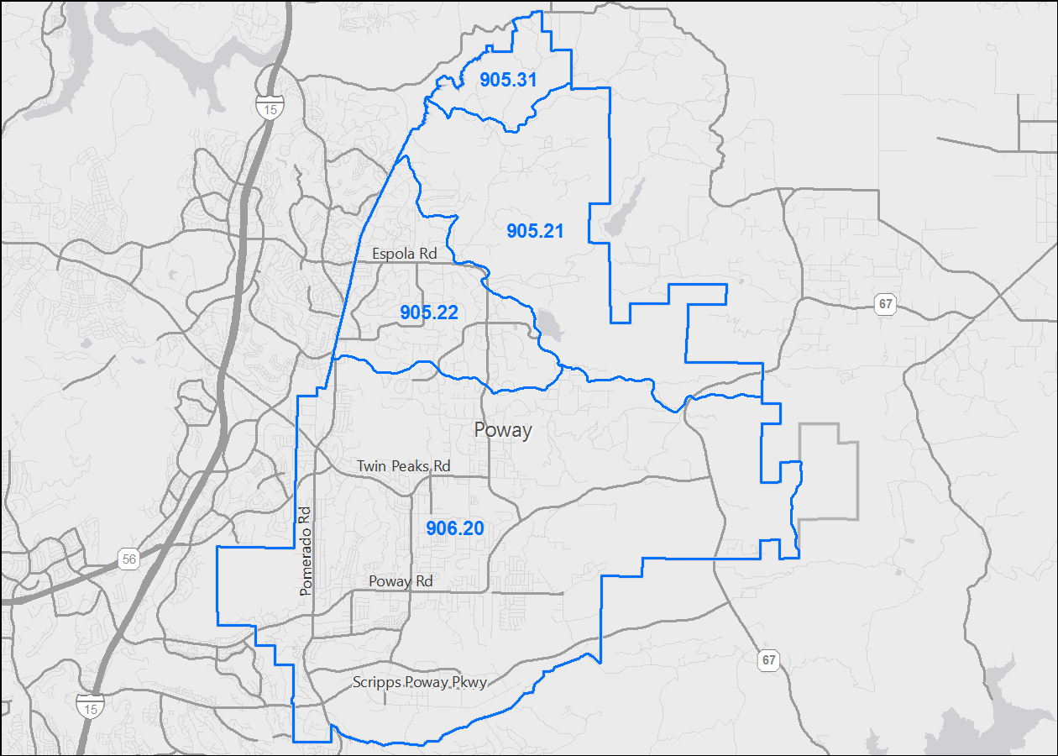

Show with an “X" the Approximate Project Location. A more detailed map is available online at http://poway.org/784/Online-Maps under the PowGIS link.
Step 3: Project type determination (Standard or Priority Development Project)
Is the project part of another Priority Development Project (PDP)? If so, a PDP SWQMP is required. Go to Step 4. |  |  |  |  | ☐Yes ☐ No  ☐ Not applicable
Justification for N/A: ☐ No exterior improvements ☐ Other: __________________________________
The project is (select one): |  |  |  | ☐ New Development ☐ Redevelopment ☐ No exterior improvements
The total proposed newly created or replaced impervious area is: |  |  |  |  | ____________________ ft²
The total existing (pre-project) impervious area is: |  |  |  |  | ft²
The total area disturbed by the project is (including contractor lay-down areas, landscape areas, and septic fields): |  |  |  |  | ____________________ ft²
If the total area disturbed by the project is 1 acre (43,560 sq. ft.) or more OR the project is part of a larger common plan of development (e.g., a building permit within a previously approved subdivision) disturbing 1 acre or more, a Waste Discharger Identification (WDID) number must be obtained from the State Water Resources Control Board.
WDID: ____________________________
Is the project in any of the following categories, (a) through (f)?
Yes  ☐ | No  ☐ | (a) | New development projects that create 10,000 square feet or more of impervious surfaces (collectively over the entire project site). This includes commercial, industrial, residential, mixed-use, and public development projects on public or private land.
Yes  ☐ | No  ☐ | (b) | Redevelopment projects that create and/or replace 5,000 square feet or more of impervious surface (collectively over the entire project site on an existing site of 10,000 square feet or more of impervious surfaces). This includes commercial, industrial, residential, mixed-use, and public development projects on public or private land.
Yes  ☐ | No  ☐ | (c) | New and redevelopment projects that create and/or replace 5,000 square feet or more of impervious surface (collectively over the entire project site), and support one or more of the following uses:  - Restaurants. This category is defined as a facility that sells prepared foods and drinks for consumption, including stationary lunch counters and refreshment stands selling prepared foods and drinks for immediate consumption (Standard Industrial Classification (SIC) code 5812).  - Hillside development projects. This category includes development on any natural slope that is twenty-five percent or greater.  - Parking lots. This category is defined as a land area or facility for the temporary parking or storage of motor vehicles used personally, for business, or for commerce.  - Streets, roads, highways, freeways, and driveways. This category is defined as any paved impervious surface used for the transportation of automobiles, trucks, motorcycles, and other vehicles.
Project Type Determination (continued)
Yes  ☐  ☐  ☐ | No  ☐  ☐  ☐ | (d) | New or redevelopment projects that create and/or replace 2,500 square feet or more of impervious surface (collectively over the entire project site), and  - Discharging directly to an Environmentally Sensitive Area (ESA). “Discharging directly to” includes flow that is conveyed overland a distance of 200 feet or less from the project to the ESA, or  - Conveyed in a pipe or open channel any distance as an isolated flow from the project to the ESA (i.e. not commingled with flows from adjacent lands).
Yes  ☐ | No  ☐ | (e) | New development projects, or redevelopment projects that create and/or replace 5,000 square feet or more of impervious surface, that support one or more of the following uses:  - Automotive repair shops. This category is defined as a facility that is categorized in any one of the following SIC codes: 5013, 5014, 5541, 7532-7534, or 7536-7539.  - Retail gasoline outlets (RGOs). This category includes RGOs that meet the following criteria: (a) 5,000 square feet or more or (b) a projected Average Daily Traffic (ADT) of 100 or more vehicles per day.
Yes  ☐ | No  ☐ | (f) | New or redevelopment projects that result in the disturbance of one or more acres of land and are expected to generate pollutants post construction.
Does the project meet the definition of one or more of the Priority Development Project categories (a) through (f) listed above?
☐No – the project is not a Priority Development Project (Standard Project or SWQMP not applicable).
☐Yes – the project is a Priority Development Project (PDP).

Further guidance may be found in Chapter 1 and Table 1-2 of the BMP Design Manual.
The following is for redevelopment PDPs only:
The area of existing (pre-project) impervious area at the project site is: |  |  |  |  |  | _________________ ft² (A)
The total proposed newly created or replaced impervious area is: |  |  |  |  |  | _________________ ft² (B)
Percent impervious surface created or replaced (B/A)*100: |  |  |  |  |  | _________________ %
The percent impervious surface created or replaced is (select one based on the above calculation):
☐less than or equal to fifty percent (50%) – only newly created or replaced impervious areas are considered a PDP and subject to stormwater requirements.
OR
☐greater than fifty percent (50%) – the entire project site is considered a PDP and subject stormwater requirements.

Step 4: Storm Water Quality Management Plan requirements
Step | Answer |  | Progression
Is the project a Standard Project, Priority Development Project (PDP), or exception to PDP definitions?  To answer this item, complete the Project Type Determination Checklist on Pages 2 and 3 of this form, and see PDP exemption information below.  For further guidance, see Section 1.4 of the BMP Design Manual in its entirety. | ☐Standard Project |  | Standard Project requirements apply, including Standard Project SWQMP.  Complete Standard Project SWQMP.
 | ☐PDP |  | Standard and PDP requirements apply, including PDP SWQMP.  Complete PDP SWQMP.
 | ☐PDP Exemption |  | Go to Step 5 below.
 | ☐Not applicable |  | The project does not require a SWQMP.
Step 5: Exemption to PDP Definitions
Is the project exempt from PDP definitions based on either of the following:  ☐ Projects that are only new or retrofit paved sidewalks, bicycle lanes, or trails that meet the following criteria:  - Designed and constructed to direct storm water runoff to adjacent vegetated areas, or other non-erodible permeable areas; OR  - Designed and constructed to be hydraulically disconnected from paved streets or roads [i.e., runoff from the new improvement does not drain directly onto paved streets or roads]; OR  - Designed and constructed with permeable pavements or surfaces in accordance with County of San Diego Guidance on Green Infrastructure; |  |  |  | If so: Standard Project requirements apply, AND any additional requirements specific to the type of project. City concurrence with the exemption is required. Provide discussion and list any additional requirements below in this form. Complete Standard Project SWQMP.
Discussion / justification, and additional requirements for exceptions to PDP definitions, if applicable:

Step 6: Certification
Applicant Certification: I have read and understand that the City of Poway has adopted minimum requirements for managing urban runoff, including storm water, from construction and land development activities, as described in the BMP Design Manual. I certify that this intake form has been completed to the best of my ability and accurately reflects the project being proposed. I also understand that non-compliance with the City’s PMC may result in Code Enforcement action by the City.
Signature of Applicant: |  | Date:
For City Only:
☐ Standard SWQMP
☐ PDP SWQMP
☐ SWQMP not applicable

Redevelopment is defined as: The creation, addition, and or replacement of impervious surface on an already developed site. Examples include the expansion of a building footprint, road widening, the addition to or replacement of a structure. Replacement of impervious surfaces includes any activity where impervious material(s) are removed, exposing underlying soil during construction. Redevelopment does not include routine maintenance activities, such as trenching and resurfacing associated with utility work; pavement grinding; resurfacing existing roadways, sidewalks, pedestrian ramps, or bike lanes on existing roads; and routine replacement of damaged pavement, such as pothole repair.
Applicants should note that any development project that will create and/or replace 10,000 square feet or more of impervious surface (collectively over the entire project site) is considered a new development.
For solar energy projects, the area of the solar panels does not count toward the total impervious area of the site.

